

Australian Education Academy Pty Ltd
2006

MATHEMATICAL METHODS
UNIT 3 & 4

TRIAL EXAMINATION 1

Reading time: 15 minutes
Writing time: 1 hour

Student’s name: ______________________________________

Directions to students
This exam consists of 8 short answer questions. Answer all questions
The marks allotted to each part of each question appear at the end of each part.
There are 68 marks available for this task.

These questions have been written and published to assist students in their preparations for the 2006 Mathematical Methods Examination 1. The questions and associated answers and solutions do not necessarily reflect the views of the Victoria Curriculum and Assessment Authority.

© Australian Education Academy Pty Ltd 2006
This Trial Examination is licensed to the purchasing school or educational organization with permission for copying within that school or educational organization. No part of this publication may be reproduced, transmitted or distributed, in any form or by any means, outside purchasing schools or educational organizations or by individual purchases without permission.

Published by Australian Education Academy Pty Ltd
ABN: 18 104 474 893
292 Mount Alexander Road, Ascot Vale. Vic. 3032
Ph: (03) 9370 0666 Fax: (03) 9375 7277
Email: wendy@aust-education.com.au

Question 1

A recent study found that X ,the number of passengers per car entering a city on the freeway on a working morning, is

X=x | 0 | 1 | 2 | 3 | 4 | 5
Pr(X=x) | 0.40 | 0.30 | 0.15 | 0.10 | 0.03 | 0.02

a. Compute E(X), the mean number of passengers per car.

[4 mark]

b. Compute Variance of X and hence standard deviation of X.

[4 mark]

c. Find Pr(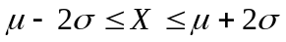) where  and denote the mean and standard
deviation respectively.

[2 mark]

[Total 10 marks]

Question 2

The height of a certain population of adult males is normally distributed with mean 174 cm and standard deviation 8 cm.

a. Find the probability that the height of a randomly selected individual will exceed 190 cm.

[3 mark]

b. If two individuals are selected at random, find the probability that both of their heights will exceed 190 cm.

[3 mark]

[Total 6 marks]

Question 3

A recreational swimming lake is treated periodically to control harmful bacteria growth. Suppose t days after a treatment, the concentration of bacteria per cubic centimeter is given by
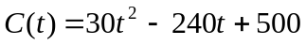, 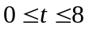

a. How many days after a treatment will the concentration be minimal?

[3 mark]

b. What is the minimum concentration?

[3 mark] [Total 6 marks]

Question 4

The function f is defined by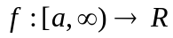, 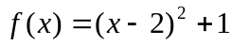

a. Find the smallest value of a such that f is one-to-one.

[2 mark]

b. With this value of a, state the range of f.

[2 mark]

c. Sketch the graph of f
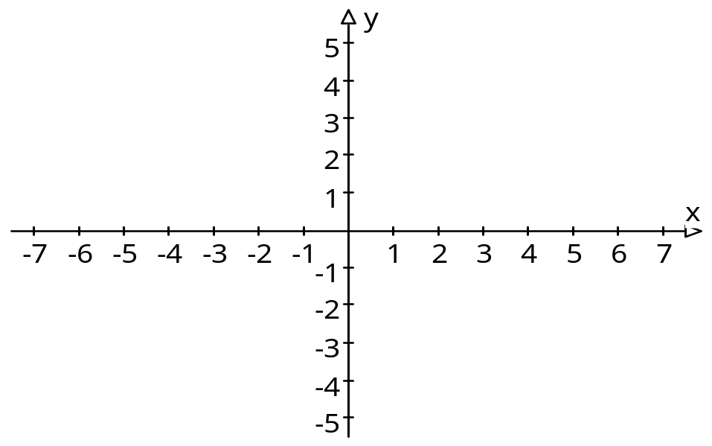
[4 mark]

d. Find the inverse function of f

[3 marks]

[Total 11 marks]

Question 5

A function f given by 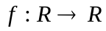,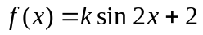, passes through the point with coordinates 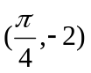.

a. Find the value of k

[3 mark]

- Determine the minimum and the maximum values of .

[4 mark]

- Find the solutions of the equation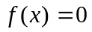 in the interval 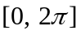

[4 marks]

[Total 11 marks]

Question 6

The graph of the function f with domain [-6,6) is shown below.
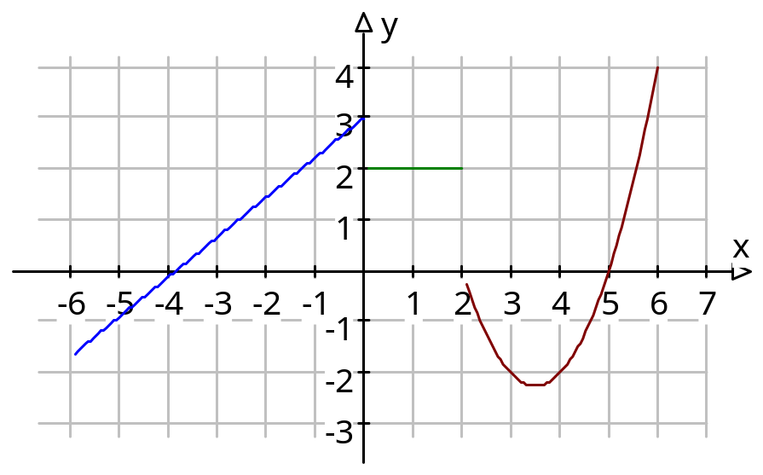
- On the set of axes below, sketch the graph of the derivative function 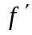.
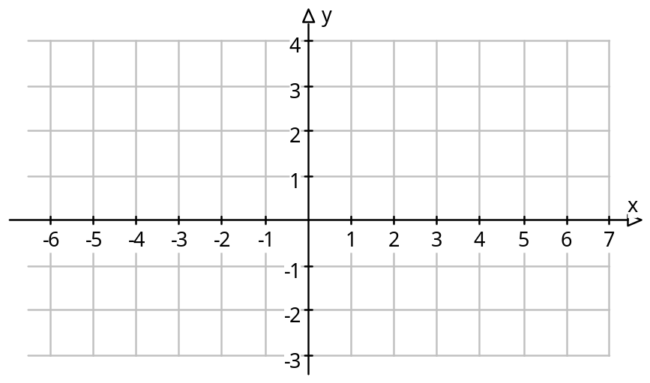
[4 marks]

- State the domain of the derivative function .

[2 mark]

[Total 6 marks]

Question 7

a. Find the x coordinates of the points of intersection of the line with equation 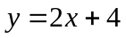and the parabola with equation 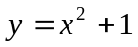.

[3 mark]

b. Sketch the two graphs on the same set of axes.
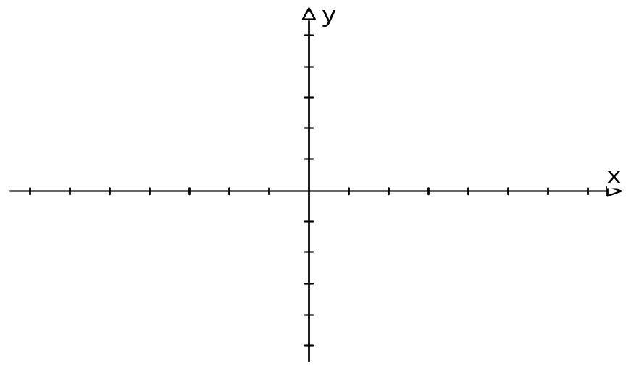
[3 mark]

c. Use calculus to find the area of the region bounded by the line with equation and the parabola with equation .

[4 mark]

[Total 10 marks]

Question 8
a. Sketch the graph of 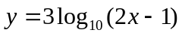

[ 4 Marks ]

b. The equation of a graph is 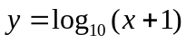 .The graph is dilated parallel to -axis by factor 3 .The graph is translated down by factor 2 .The graph is translated to the right by factor 3 .Write down the equation of the curve .

____________________________________________________________________

_____________________________________________________________________

_____________________________________________________________________

_____________________________________________________________________

_____________________________________________________________________
[4 mark]
[Total 8 marks]

